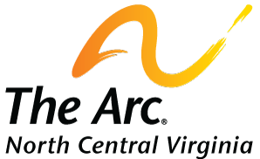

MEMBERSHIP FORM

First Name: ______________________ Last Name: __________________________
Email: __________________________ Phone Number: __________________________
Street Address: __________________________________________________________________
Street Address 2: _________________________________________________________________
City: _________________ State: _____________ Postal / Zip Code: ______________

Membership Type:
- Individual ($20) | - Family ($25) | - Nonprofit ($50)

Today’s Date: ______________________

If a Family Membership, please list the other names in your family: _______________________________________________________________________________________________________________________________________________________________________________________________________________________________________________________________

Comments: _______________________________________________________________________________________________________________________________________________________________________________________________________________________________________________________________

Please send with payment to: The Arc of North Central VA | PO Box 3186 | Warrenton, VA 20188

